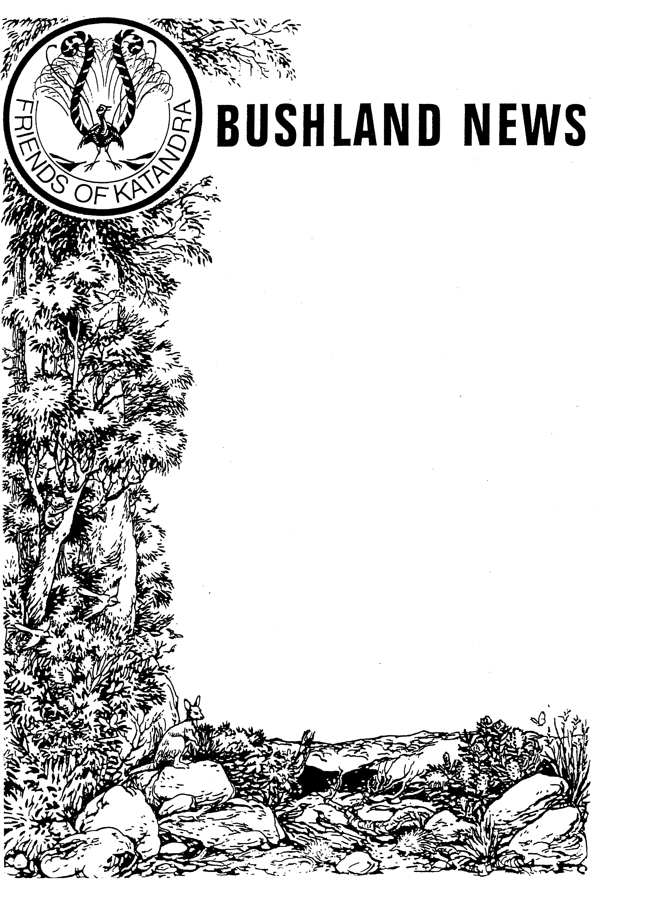

KATANDRA BUSHLAND SANCTUARY NEWSLETTER

Spring 2025
Greetings from Katandra

Katandra’s 2025 open season has been busy, despite losing a few days due to poor weather. The Sanctuary will continue to be open every Sunday 10am to 4pm from now until the end of October.
Volunteer Week is celebrated in May each year, this year’s theme was “connecting communities”, highlighting the impact of volunteering in building thriving communities. This year Crown Lands featured Katandra as a wonderful example of a community asset, administered and maintained by volunteers, visiting the Sanctuary to present a volunteering award. Articles posted by Crown Lands can be seen on their website (www.crownland.nsw.gov.au/news) or on the nswdphi (Dept of Planning, Housing and Infrastructure) facebook page. Following this, ABC radio conducted an interview about Katandra on its weekend morning show and Pittwater Life magazine published a feature article on Katandra in their September edition. Many visitors to Katandra have mentioned hearing or seeing these articles.

Visitors have also regularly seen wallabies, goannas and a wide variety of birds on their walks, along with many plants flowering including Toothed Phebalium (Leionema dentatum), Holly-leaf Pea (Oxylobium ilicifolium), Large-leaf Bushpea (Pultenaea daphnoides), Sydney Boronia (Boronia ledifolia), Soft Boronia (Boronia mollis), Prickly Moses wattle (Acacia ulicifolia), Twining Guinea Flower (Hibbertia dentata), Silky Needlebush (Hakea sericea), False Sarsaparilla (Hardenbergia violacea),

You can contact us by email katandrainfo@gmail.com, phone 0431857407 or via the Contact Us page on the Katandra website.

We look forward to seeing you at Katandra.

David Seymour

Mother of Millions or Christmas Bells?

At first glance, the two bunched tube-shaped flowers shown on these pages look similar, however the plants producing these flowers are very different. One is a much-loved native of the area, the other a serious exotic weed spreading across many areas of NSW.

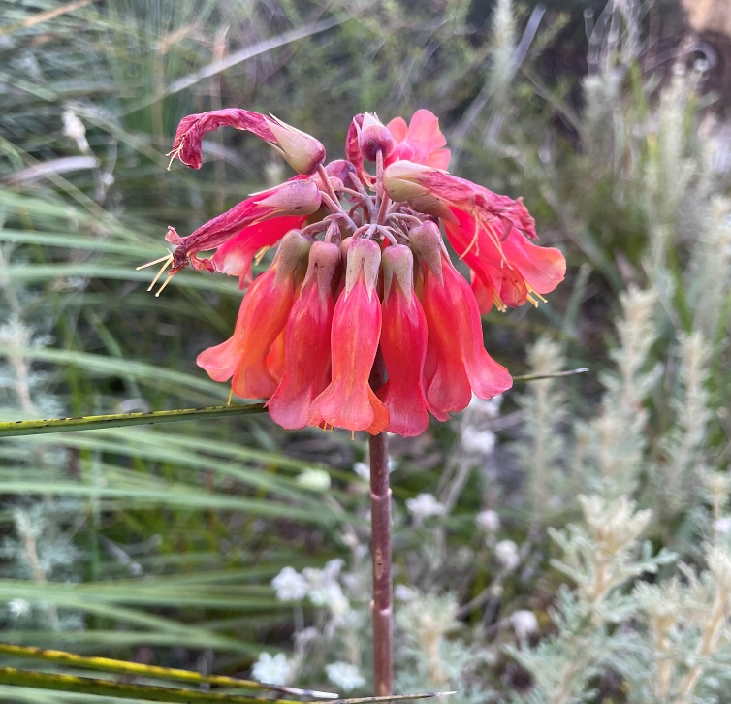

The reddish, drooping flowers of Bryophyllum delagoense (Mother of Millions)

Bryophyllum delagoense (Mother of Millions)

Mother of millions is a hardy, succulent perennial plant which is a native of Africa and Madagascar. It was introduced to Australia as a garden plant and has become a serious weed on the coast and the northwest slopes and plains of NSW. As the name suggests it reproduces rapidly, producing many tiny plant-lets that quickly form new colonies. Well adapted to dry conditions, it can survive long periods of drought. Mother of millions is commonly found growing in gravel and sandy soils, disturbed sites such as roadsides and along fence lines or even on top of rock outcrops. It also occurs frequently along creeks and rivers where it is spread by floodwaters.
Growing 30cm to 1m in height, the erect stems are pinkish-brown or greyish in colour. The leaves are pencil-shaped, opposite, pale green to pale brown in colour with dark green patches and a shallow groove on the upper surface. There are up to seven projections at the tip of each leaf which when broken off can develop into new plants. The flowers are orange-red in colour and occur in a cluster at the top of a single stem. The sepals are small, acute and fused for more than half the length. The petals are also fused forming a tube. Flowering can occur from May to October.
Mother of millions is poisonous when ingested. The toxic effects of these plants is due mainly to the presence of bufadienolides, a class of chemical compounds with a steroid structure which can cause heart failure. The toxins are present in all parts of the plant, however, the flowers are five times more poisonous than the leaves and stems. Grazing animals are particularly at risk of poisoning. Ingestion of the toxins can be cumulative and livestock eating small amounts, several times within a few days may suffer poisoning. Information from the NSW Department of Primary Industry suggests that eating about 5 kg of mother of millions would kill an adult cow. Where the plants are thick, this amount would grow in a square metre. It has been estimated that that bufadienolide-containing plants like Mother of Millions are responsible for about one third of all plant-poisoning related mortality among cattle in South Africa.
Mother of Millions are also poisonous to humans and household pets, thought is unlikely that humans or pets would eat enough plant material to become significantly poisoned.

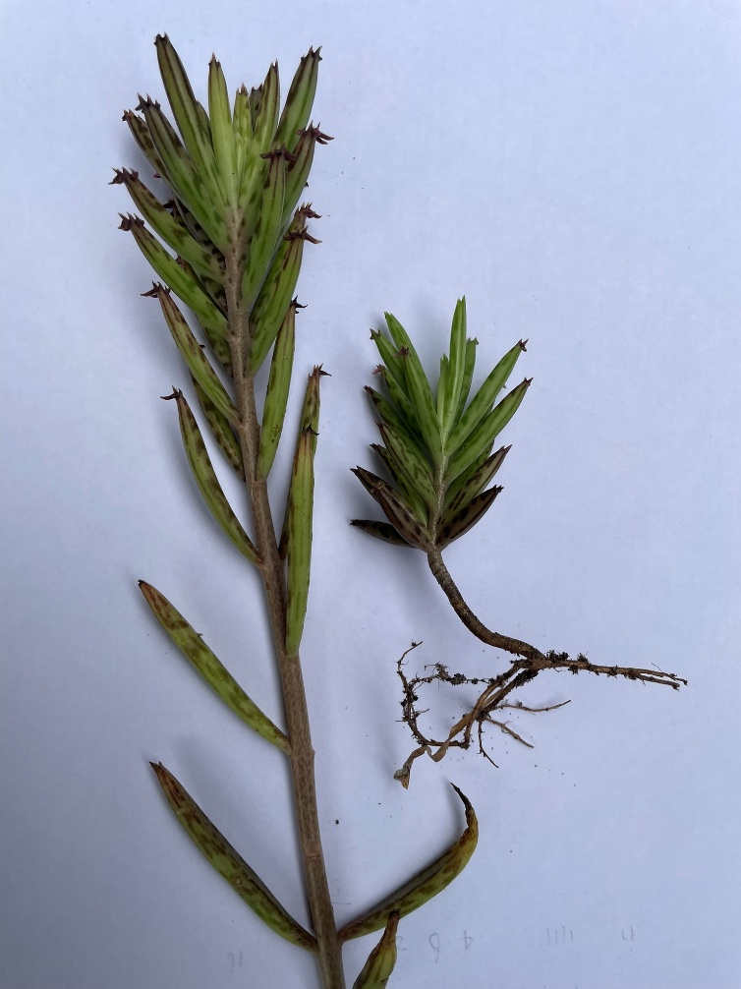

Bryophyllum delagoense (Mother of Millions)

For small infestations, mother of millions can be removed by pulling up individual plants by hand. Care needs to be taken as plantlets may detach from the leaves during removal and establish as new plants. Once the plants have been removed, they should be burnt or stored in black plastic bags until completely decayed. Follow up treatment of the area will be required as some regrowth will likely occur.
For large infestations, a hot fire is the most economical control option available and will kill the plants and much of the seed stored in the soil.

Blandfordia nobilis (Christmas Bells)

Blandfordia, commonly known as Christmas bells, is a genus of four species of flowering plants native to eastern Australia. Blandfordia nobilis is the species that grows in the Sydney area including Katandra. Common in moist open heath on sandstone it is often described as one of the most beautiful and popular of the local native flowers. The species name “nobilis” is a Latin word meaning "famous", "celebrated" or "noble".

“For all the flowers that grow there are none so dear to the heart of a Sydney-sider …” – Amy Mack, 1911, Bushdays

B. nobilis was also the subject of a Christmas song “My Little Christmas Belle” by Joe Slater and Ward McAlllister published in 1909.

Christmas bells are tufted, perennial herbs with narrow, linear leaves growing from a fleshy underground corm with fibrous roots.
The drooping, cylindrical or bell-shaped flowers are arranged in clusters on erect stems, 50 to 100cm long, which extend above the foliage. The number of flowers per stem varies, as does their colour. The most common form is red with a yellow edge, but bells vary from dark red with yellow edging to all yellow. Flowering occurs over summer, hence the name Christmas bells.

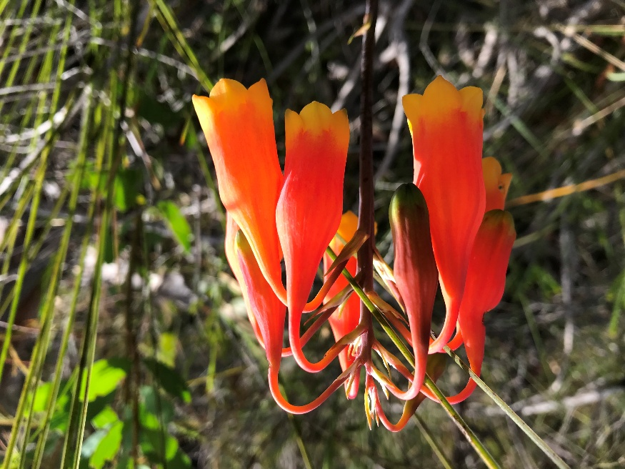

Christmas bells growing in Katandra

A Legacy of Katandra

Katandra originated from a gift of land to the NSW Government by Harold Seymour in 1967. Having purchased the land in 1946, it was his desire that the land be kept in its natural state for the benefit of both the people of NSW as well as the local flora and fauna that live in it. Harold’s generosity, which now sees this land in public ownership, has since inspired others to follow his lead.
In the early 2000’s local resident and land-owner Marjorie Roberts, who had known Harold, approached the Katandra Trust to investigate how she might also be able to preserve the native bushland on her land on her passing. Marjorie continued to live on her land into her old age despite being blind and requiring the assistance of a guide-dog. As a result of her generosity, about 5 acres of land in Walana Cresent Mona Vale, adjacent to Katandra, is now in public ownership.

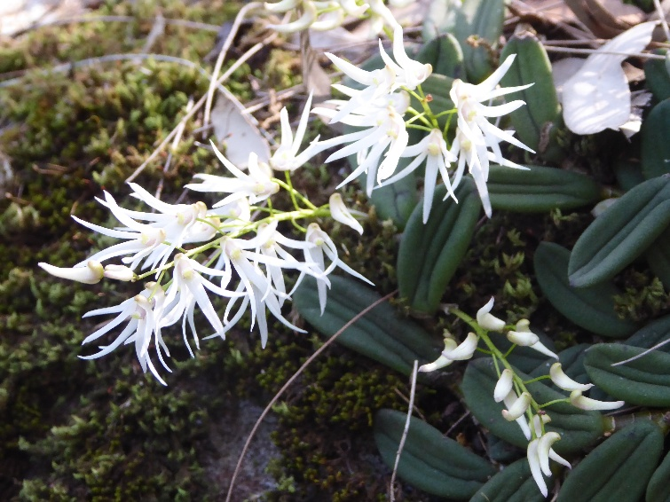

Dendrobium linguiforme (Tongue Orchid) in flower on a rock outcrop on land formerly owned by Marjorie Roberts

More recently another parcel of undeveloped land has come into public ownership as a result of its owner’s generosity. Lynette O’Neill and her husband, who purchased the land many decades ago, also knew Harold Seymour and had visited Katandra. Lynette indicated that Harold’s success in preserving his land by passing it into public ownership inspired her decision to do the same. This parcel of land, in Grandview Drive Newport, is a wonderful example of the bushland that once covered a much larger area of Newport, containing a variety of magnificent trees and over 50 other species of native flora.

No doubt there are many other stories of land preservation through the generosity of people like Harold, Marjorie and Lynette. The local communities are the fortunate beneficiaries.
KATANDRA BUSHLAND SANCTUARY
Foley’s Hill, Lane Cove Rd, Ingleside NSW
Department of Lands Reserve No 86487
Founder: the late Harold Alfred Seymour
Managed by Katandra Bushland Sanctuary Trust. Phone: 0431857407

OPEN: Every Sunday: July, August, September, October
HOURS: 10 am — 4 pm
ADMISSION: $5 donation

KATANDRA BUSHLAND SANCTUARY TRUST
PO Box 485 Mona Vale NSW 1660

President: David Seymour
Vice-President; Marita Macrae
Treasurer: Peter Hammond
Trustees: Marita Macrae OAM
Antony Westwood
Myles Holloway
Bushland News Editors: Marita Macrae OAM
David Seymour

(Cover Design by the late Walter Cunningham)

Enquiries: phone – 0431 857 407,
email - katandrainfo@gmail.com
or via the Contact Us page on the Katandra website

Katandra website - katandrabushlandsanctuary.com

Katandra Bushland Sanctuary Trust
PO Box 485 Mona Vale NSW 1660

DONATIONS

Donations to Katandra to help maintain the Sanctuary can be made by direct deposit. Katandra’s bank details are below

Account Name –
Katandra Bushland Sanctuary Trust
BSB – 082132
Account No. - 509347998

PUBLIC OPEN DAYS 2025

Each Sunday of July–October
10 am – 4 pm

Picnic tables are available for use should you wish to bring along a picnic lunch to enjoy in the Sanctuary.

DIARY DATES 2025

SANCTUARY MAINTENANCE 2025
Maintenance days are generally the third Sunday of the month from March to November, from 9am.
Please check by contacting us on 0431 857 407 as these dates and times may vary.

Volunteers are needed
If you can assist on maintenance days or with welcoming visitors to Katandra on open days, please phone 0431 857 407.

